**COS40007 Artificial Intelligence for Engineering**

**Portfolio Assessment-4: Deep Learning using TensorFlow and Keras**

**Name:** Tahmidul Haque Chowdhury  
**Student Number:** 103541308   
**Studio Class:** Studio 1 (BA 405)

**Task 1: Developing CNN and ResNet50 Models**

**Overview**

In this task, I built two models using TensorFlow and Keras: a simple CNN model and a ResNet50 model. These models were trained to classify images into two categories – rust and no rust.

**Steps Taken**

1. **Dataset Preparation:**
   * I separated 10 rust and 10 no rust images to create a test set.
   * The rest of the images were used to train the models.
2. **Training the Models:**
   * First, I trained a basic CNN model.
   * Then, I trained a ResNet50 model using the same data.
3. **Results:**
   * CNN model: Achieved 85% accuracy on the test set.
   * A screen shot of a computer code

     Description automatically generated
   * ResNet50 model: Achieved 50% accuracy on the test set.

**Task 2: Log Counting Task**

**Overview**

Although I was unable to develop the Mask R-CNN model as I was repeatedly having trouble, I still completed the log counting task using predictions from the CNN and ResNet50 models.

**Steps Taken**

1. Generating Predictions:
   * I loaded the test images and predicted whether they contained rust or not.
2. Counting Logs:
   * I wrote a Python program to count logs based on the predictions.
   * The results were saved in a CSV file for easy review.
3. Results:
   * Total Logs Counted: 20
   * CSV file with results is included in the submission.

**Task 3: New Class Labelling**

**Overview**

For this task, I updated the labels of some images using LabelMe.

**Steps Taken**

1. Using LabelMe:
   * I opened the images that were labeled as "log" in Studio 5.
   * I re-labeled the broken logs as "detected_log" and saved the updated annotations.
2. Files:
   * The updated images and annotations are included in the submission

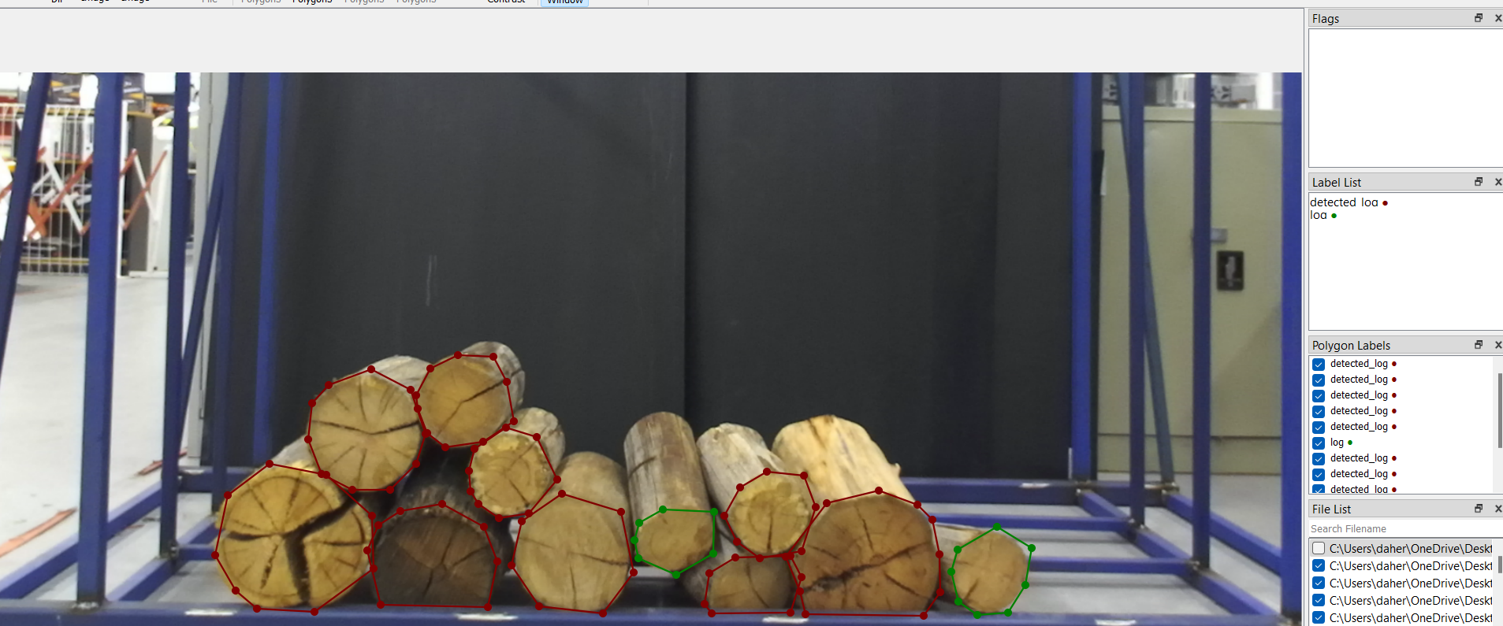.

**Submission Files**

1. CNN Test Results: In the cnn_test folder.
2. ResNet50 Test Results: In the resnet50_test folder.
3. Updated Log Dataset: Includes re-labeled images and JSON files.
4. Source Code: All Python code in the code folder.
5. Log Counts: CSV file with log counts.

**Conclusion**

This project helped me learn how to develop, train, and test deep learning models using TensorFlow and Keras. I also gained experience working with image annotations and creating a log counting program.